**REG NO:**

**SRM Institute of Science and Technology**

**College of Engineering and Technology**

**School of Computing**

SRM Nagar, Kattankulathur – 603203, Chengalpattu District, Tamilnadu

**Academic Year: 2023-24 (ODD) Descriptive Question Paper**

**Test: CLA-T3** **Date: 09-11-2023**

**Course Code & Title: 18CSE308T -AWS Solution Architect** **Duration:** **80 Minutes**

**Year & Sem: III Year / V Sem** **Max. Marks:** **40**

**Course Articulation Matrix: *(to be placed)***

|  |  |  |  |  |  |  |  |  |  |  |  |  |  |
| --- | --- | --- | --- | --- | --- | --- | --- | --- | --- | --- | --- | --- | --- |
| **S.No.** | **Course Outcome** | **PO1** | **PO2** | **PO3** | **PO4** | **PO5** | **PO6** | **PO7** | **PO8** | **PO9** | **PO10** | **PO11** | **PO12** |
| 1 | **CO1** | 2 |  |  |  | 3 |  |  |  |  |  |  |  |
| 2 | **CO2** | 3 |  |  |  |  |  |  |  |  |  |  |  |
| 3 | **CO3** | 2 |  |  | 3 |  |  |  |  |  |  |  |  |
| 4 | **CO4** |  | 3 |  |  |  |  |  |  |  |  |  |  |
| 5 | **CO5** |  |  |  | 3 |  |  |  |  |  |  |  |  |

|  |  |  |  |  |  |  |
| --- | --- | --- | --- | --- | --- | --- |
| **Part - B**  **(5 x 4 M = 20 Marks)**  **Instructions: Answer any 5. NOTE: 3 Questions from Unit 4 & 2 Questions from Unit 5 has to be answered.** | | | | | | |
| **Q. No** | **Question** | **Marks** | **BL** | **CO** | **PO** | **PI Code** |
| **11** | Explain the fundamental difference between containers and virtual machines (VMs) in terms of architecture and resource utilization. | **4** | **L2** | **4** | **1** | **1.6.1** |
| **12** | Explain the key components and AWS services commonly used in building a microservices architecture on AWS. | **4** | **L2** | **4** | **2** | **2.6.4** |
| **13** | Explain the architecture of Amazon Redshift, including its components like nodes, clusters, and data distribution styles. | **4** | **L2** | **4** | **1** | **1.6.1** |
| **14** | Describe a practical use case for AWS Glue in a data processing pipeline. Outline the steps involved in creating and running an ETL job using AWS Glue. | **4** | **L2** | **4** | **1** | **1.7.1** |
| **15** | Describe the concept of CloudWatch Agent and its role in collecting custom metrics from EC2 instances. | **4** | **L2** | **4** | **2** | **2.6.4** |
| **16** | Describe the AWS Global Accelerator service and its role in enhancing DDoS protection in AWS Shield. | **4** | **L2** | **5** | **1** | **1.6.1** |
| **17** | Explain the main types of web application attacks that AWS WAF is designed to protect against. | **4** | **L2** | **5** | **1** | **1.7.1** |
| **18** | Explain the key concepts of IP addressing within an Amazon VPC, including CIDR notation, public and private IP addresses, and Elastic IP addresses. | **4** | **L2** | **5** | **2** | **2.6.4** |
| **Part - C**  **(2 x 10 M = 20 Marks)** | | | | | | |
| **19** | 1. a) Examine the thought process you would employ as the leader of a team responsible for containerizing an existing monolithic application. Discuss your in-depth analysis of the steps involved in breaking down the monolith into containerized microservices, with a special emphasis on architectural design, deployment strategies, and techniques for seamless communication among the microservices   Or   1. Analyze the critical decisions and considerations you would take into account when architecting a data warehousing solution for a retail company dealing with extensive sales data. Evaluate your approach to creating and optimizing a data schema in Amazon Redshift, specifically focusing on its ability to handle complex queries and reporting requirements | **10** | **L3** | **4** | **1** | **1.7.1** |
| **20** | 1. Examine the intricate thought process you would apply as the lead architect entrusted with crafting a startup's multi-tiered web application. Provide an in-depth assessment of the strategies employed for configuring subnets, security groups, and route tables in Amazon VPC, with a focus on achieving network isolation and ensuring uninterrupted high availability for the application.   Or   1. Analyze the critical decisions and factors you would take into account as a security expert when dealing with a complex web application frequently targeted by a variety of attacks. Evaluate your approach to proactively monitoring and fine-tuning AWS WAF, emphasizing its role in providing effective protection against evolving threats | **10** | **L3** | **5** | **2** | **2.6.4** |

**\*Program Indicators are available separately for Computer Science and Engineering in AICTE examination reforms policy.**

**Course Outcome (CO) and Bloom’s level (BL) Coverage in Questions**

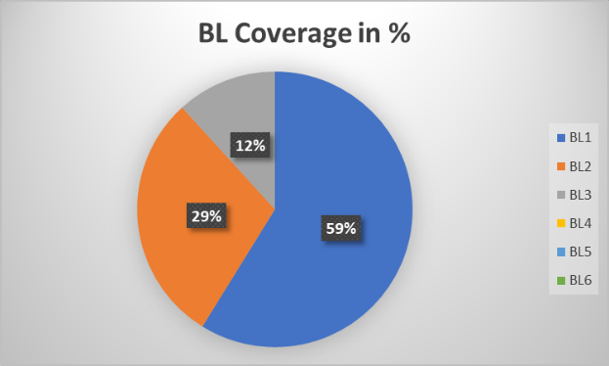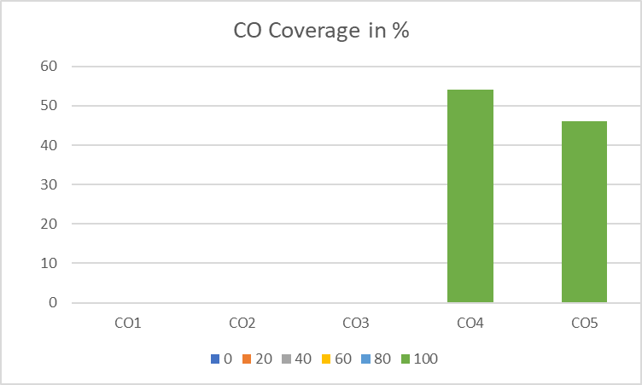

**Approved by the Audit Professor/Course Coordinator**